COVID-19 infection control training
This 30-minute online training module is for health care workers in all settings. It covers the fundamentals of infection prevention and control for COVID-19.
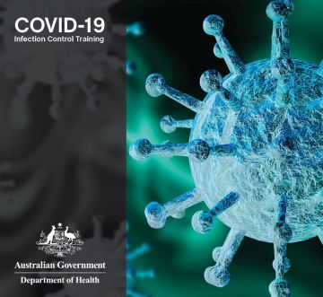
This training is for care workers across all health care settings, including:
- aged care (both in residential aged care facilities or with visiting carers at home, including cleaners and cooks)
- disability (both in residential/shared care facilities or part-time carers in people’s homes, including cleaners and cooks)
This training module covers the fundamentals of infection prevention and control for COVID-19 including:
- COVID-19 – what is it?
- Signs and symptoms
- Keeping safe – protecting yourself and others
- Myth busting
Users must register, but registration is open to anyone.
Register now
https://covid-19training.com.au/login.php

